Enhancing E-Learning Experiences through AI Integration: A Case Study Analysis of Personalized Learning Paths

AUTHORS

Kunal Kumar, Abhishek Mourya, Nimanshu Jain , Ritu Dayal and Radha Dronacharya Group of Institution
Knowledge Park III, Greater Noida, Uttar Pradesh 201306
{ kunal73014, abhishekmouryaak1, nimanshujain2611, sonamlodhi65 , radhakumari8178622 }@gmail.com

Prof. Shantanu (Mentor) Dronacharya Group Of Institution

Knowledge Park III, Greater Noida, Uttar Pradesh 201306

Abstract - This paper offers a research-driven analysis based on a comprehensive review of literature spanning the past decade, focusing on learner modeling and personalized learning environments. Synthesizing insights from various case studies and empirical findings, the analysis delves into methodologies such as adaptive hypermedia, predictive student modeling, emotion recognition methods, and personalized recommendation systems.
Through systematic examination, common themes, challenges, and future directions in learner modeling and personalized learning environments are identified, emphasizing the importance of understanding students’ learning styles, cognitive factors, and affective states. The paper discusses implications for designing personalized learning systems tailored to individual learners’ needs and preferences.
Integrating findings from multiple studies, this analysis contributes to understanding the complexities of learner modeling and personalized learning, providing insights for researchers, practitioners, and educators. Leveraging learner data and advanced analytic, the research emphasizes interdisciplinary collaboration and the integration of emerging technologies like AI and machine learning to develop sophisticated learner models and personalized learning environments.

Keywords-Personalized learning, Adaptive learning, Learner modeling, Educational technology, Case study, Systematic literature review

INTRODUCTION
- Defining E-Learning and AI Integration
In the digital age, the convergence of technology and education has transformed the way we teach and learn. One of the most significant advancements in this domain is the integration of Artificial Intelligence (AI) into E- learning platforms, revolutionizing the landscape of online education. AI, the simulation of human intelligence pro- cesses by machines, offers unprecedented opportunities to enhance the effectiveness, efficiency, and accessibility of learning experiences in virtual environments.
AI-driven innovations in E-learning encompass a wide range of applications, from personalized learning paths and intelligent tutoring systems to automated assessment and feedback mechanisms. By harnessing the power of AI algorithms, E-learning platforms can adapt to individ- ual learner needs, deliver tailored content, and provide real- time support, creating more engaging and effective educational experiences.
This research paper aims to explore the multifaceted landscape of AI integration in E-learning platforms, ex-
1

amining key trends, challenges, and opportunities shaping the future of online education. By analyzing real-world case studies and use cases, we seek to provide valuable insights that inform the design, implementation, and eval- uation of AI-driven innovations in educational settings.

- Objectives for Enhancing E-Learning Experiences through AI Integration
Unlocking the Potential of AI in E-Learning: Objectives for Investigating Personalized Learning Paths, Intelligent Tutoring Systems, and Automated Assessment
This study aims to explore various objectives for lever- aging AI in E-learning platforms:
Firstly, the investigation will focus on the effectiveness of AI-powered personalized learning paths. By analyzing how AI algorithms analyze student data, the study seeks to understand how tailored learning pathways in E-learning platforms impact student engagement and learning out- comes.
Secondly, the study will evaluate the role of Intelligent Tutoring Systems (ITS) in enhancing student learning. By

examining the effectiveness of ITS in providing person- alized feedback, guidance, and support to learners, the research aims to identify factors contributing to its success or limitations in educational settings.
Thirdly, the research will assess the accuracy and ef- ficiency of automated assessment and feedback tools. By evaluating the reliability and efficiency of AI-driven tools for automated grading, assessment, and feedback in E-learning platforms, the study aims to identify best practices for their implementation and integration.
Furthermore, the study will explore the ethical consid- erations and implications of AI integration in E-learning. This includes investigating issues of algorithmic bias, data privacy, and fairness, and proposing strategies for addressing these concerns in educational settings.
Lastly, the research will provide recommendations for future research and practice in AI-enhanced education. By synthesizing the findings of the study, the aim is to offer recommendations and guidelines for educators, policymakers, and researchers seeking to leverage AI tech- nologies to enhance teaching and learning experiences in E-learning environments.

LITERATURE SURVEY
In exploring the integration of Artificial Intelligence (AI) in E-learning platforms to enhance personalized learning paths, several key studies provide valuable insights.
  - Personalized Learning Paths: [1] conducted a sys- tematic review of learner modeling literature, emphasiz- ing the importance of tailored learning pathways. They highlighted methodologies for individualized instruction, essential for optimizing learning experiences.
  - Intelligent Tutoring Systems (ITS): Jeremic´, Z., Jo- vanovic´, J., and Gaševic´, D. (2012) [2] explored the role of ITS in software pattern tutoring, stressing the significance of personalized feedback. Similarly, García, P., Schiaffino, S., and Amandi, A. (2008) proposed enhanced models for detecting learning styles, vital for developing adaptive tutoring systems.
  - Automated Assessment and Feedback Tools: Castillo, G., Gama, J., and Breda, A. M. (2006) developed an adap- tive predictive model for student modeling, crucial for automated assessment mechanisms. Additionally, Pelánek,
educators and policymakers seeking to leverage AI to enhance personalized learning experiences.

METHODOLOGY
This study employs a qualitative research approach, specifically a case study analysis, to investigate the im- plementation and effectiveness of personalized learning paths through AI integration in E-learning environments. The methodology involves the following steps:
- Case Selection: Selection of relevant E-learning plat- forms that have integrated AI-driven personalized learning features. Platforms chosen for analysis demonstrate a variety of approaches to personalized learning, including adaptive learning algorithms, intelligent tutoring systems, and automated assessment tools.
- Data Collection : Gathering data from selected E- learning platforms, including user interaction data, system logs, learner profiles, and feedback mechanisms. Data collection methods may include direct observation, user surveys, interviews with platform developers, and analysis of system-generated reports.
- Data Analysis: Employing qualitative analysis tech- niques to examine the collected data. This includes the- matic analysis to identify patterns, trends, and chal- lenges related to personalized learning implementation. Additionally, comparative analysis may be conducted to assess the effectiveness of different AI-driven features in enhancing learning experiences.
- Case Study Presentation: Presenting findings from the case study analysis in a structured format, including descriptions of the selected E-learning platforms, their AI integration features, and the observed impact on learner engagement, satisfaction, and learning outcomes.
- Cross-Case Synthesis : Synthesizing findings across multiple case studies to identify common themes, chal- lenges, and best practices in implementing personalized learning paths through AI integration. This synthesis pro- vides a comprehensive understanding of the effectiveness and limitations of AI-driven personalized learning in di- verse educational contexts.
- Ethical Considerations : Ensuring ethical conduct throughout the research process, including obtaining in- formed consent from participants, protecting learner pri- vacy and confidentiality, and adhering to ethical guide-

R., Papoušek, J.,
Rˇihák, J., Stanislav, V., and Nižnan, J.
lines for data collection and analysis.

(2017) [3] introduced Elo-based learner modeling, enhanc- ing automated assessment capabilities.
- Ethical Considerations and Implications: Imani, M., and Montazer, G. A. (2019) [4] surveyed emotion recogni- tion methods in E-learning, highlighting ethical consider- ations for learner privacy. Tourtoglou, K., and Virvou, M. (2012) [5] examined ethical implications of recommender systems, stressing fairness and transparency.
- Future Directions and Recommendations: Wang, Jingjing, Haoran, et al. (2021) [6] investigated personalized recommendation systems, offering insights for future AI integration. Their study provides recommendations for
By employing a case study analysis methodology, this research aims to provide valuable insights into the im- plementation and impact of personalized learning paths through AI integration in E-learning environments.
- CASE STUDY: ANALYSIS OF PERSONALIZED LEARNING
PATHS

Introduction
The integration of artificial intelligence (AI) into e- learning has propelled the evolution of educational prac- tices, offering tailored learning experiences through per- sonalized learning paths and intelligent tutoring systems.

AI algorithms, capable of analyzing vast datasets and adapting in real-time, enable the creation of personalized learning pathways that dynamically adjust to individ- ual learner profiles. This technical innovation holds the promise of optimizing learning outcomes by addressing diverse needs and learning styles while also presenting opportunities for scalability and efficiency in educational delivery.
In this paper, we conduct a detailed case study analysis to explore the technical intricacies and efficacy of AI- driven personalized learning paths and intelligent tutoring systems within e-learning environments. By examining real-world implementations, we aim to assess the effec- tiveness of AI integration, analyze user experiences, and uncover insights into the technical design, implementa- tion, and optimization of these systems. Through our investigation, we seek to contribute empirical evidence and technical insights to the discourse surrounding AI in education, informing future developments and best practices in e-learning technology.

Related Works
Personalizing learning is a complex endeavor, with the learner model serving as a critical component of adaptive learning environments. Research in this area has emphasized the significance of learner modeling due to its profound impact on improving the learning process. While early studies primarily focused on assessing the learner’s knowledge level, there has been a growing interest in modeling additional characteristics such as learning style, motivation, and affective aspects (Chrysafiadi and Virvou, 2013 [7]).
Various approaches to learner modeling have been proposed, utilizing different techniques and characteris- tics. Hybrid techniques have gained traction for modeling learner characteristics, with machine learning methods being particularly prevalent.
Efforts to personalize the learning experience have ex- plored integrating emotions, learning styles, and person- ality into the model . This involves employing question- naires and tests to define personality data and learning styles. Additionally, automatic detection of learning styles through the exploitation of learners’ navigation data has been investigated (Sweta and Lalet, 2017; Aryal et al., 2019 ).
Recent advancements include the development of hy- brid recommendation systems tailored to group discus- sions (Riyahi and Sohrabi, 2020 [8]), adaptive learning systems incorporating cognitive and affective factors, and personalized learning paths considering various learner attributes. These initiatives have demonstrated significant potential in improving learning outcomes and enhancing learner satisfaction.
In summary, research in personalized learning has evolved to encompass a diverse range of methodologies and technologies aimed at optimizing the learning expe- rience. From hybrid modeling techniques to personalized
recommendation systems, these advancements continue to shape the future of education.

Methodology
To address the researchers’ concerns regarding person- alizing the learning process to mitigate dropout rates, sig- nificant attention has been directed towards constructing a precise and comprehensive learner model. Drawing from various studies discussed in the preceding section, our methodology aims to address three fundamental inquiries:
- Which aspects of the learner’s information and char- acteristics should be modeled? (2) What methodologies should be employed for modeling these aspects? and (3) In what ways will the model be applied?
Our proposed model integrates pertinent learner in- formation and characteristics through the utilization of learner modeling methodologies, fuzzy logic, and similar- ity techniques.

The Architecture of the Proposed System
Learner modeling stands as a pivotal precursor to realiz- ing personalized learning services, enabling not only the representation of the learner’s profile but also fostering interactive engagement within the system. As asserted by (Millán et al., 2010; Nguyen and Do, 2009 ), elaborating upon the model necessitates identifying pertinent infor- mation, determining the modeling approach, and outlin- ing its utilization to achieve personalized learning adapta- tions. Consequently, the development of a learner model revolves around three central inquiries: What learner in- formation and characteristics are essential for modeling? How should these elements be modeled? and How will the model be applied?
In comparison to traditional classroom settings, learn- ers in digital learning environments commence their jour- ney by establishing their identities. Hence, the initial query to address is: "What information is pertinent prior to the commencement of the learning process?" This inquiry corresponds to static information types, as delineated by, which encompass data predefined by the learner before initiation and remain unchanged throughout unless mod- ified by the learner. Concurrently, dynamic information unfolds during the learning journey, resulting from the learner’s interactions with the environment, continuously updated by the system based on collected data.
Furthermore, Brusilovsky (2001) categorizes data into two distinct groups based on their nature and form: domain-specific information (DSI) and domain- independent information (DII). DSI encompasses knowledge levels, skill proficiencies, and learning activity records directly tied to the content domain. Conversely, DII, unrelated to content, streamlines personalization processes by encompassing learning objectives, cognitive abilities, motivation levels, learning styles, background insights, and preferences.
  - Unveiling the Learner’s Traits:
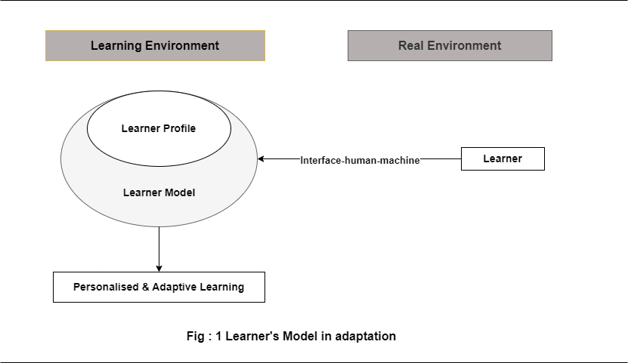

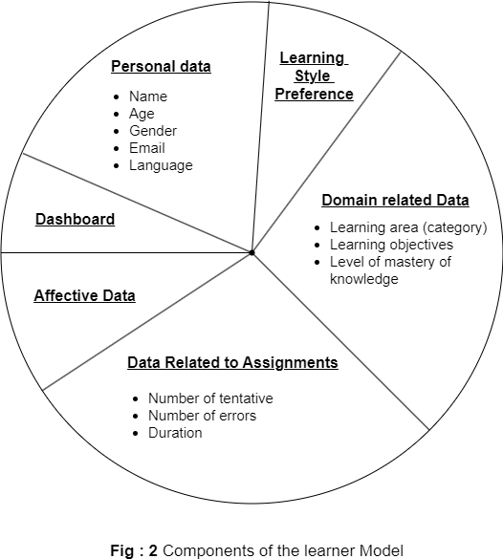
    - Profile and Model of the Learner: Prior to delving into the parameters incorporated into our model, it’s pertinent to delineate between two frequently used terms in this domain: "Learner Profile" and "Learner Model" (see fig. 1). The Learner Profile encompasses raw personal information of the learner, such as name, email, and gender, devoid of interpretation. On the other hand, the Learner Model encapsulates a comprehensive description of the learner’s pertinent knowledge and behaviors within the educational context, aiming to tailor the system to each learner’s needs (De Koch, 2001 [9]). Consequently, the Learner Model provides a holistic overview capable of deducing additional insights about the learner, beyond the surface-level data (Nguyen and Do, 2008 [10] ). In the real learning environment, the system perceives the learner through the "human-machine interface".
    - Elements of a Learner Model: The information
extracted constitutes the data stored within the learner’s model, enabling analysis and restructuring to facilitate system optimization. This learner model assumes a pivotal role as the initial stage in personalized learning. Refer to Figure 2 for an illustration of the components comprising our learner model.
For each learner, the model encompasses:
- Personal Data: This section includes preliminary identification details such as name, age, gender, email, and preferred language. While essential, this learner-defined data holds lesser significance in the personalization of learning.
- Learning Style Preference: This aspect, extensively discussed in educational psychology literature, elu- cidates how a learner perceives, engages with, and responds to learning content in a personalized man- ner conducive to optimal learning outcomes. Ac- knowledging this characteristic is agreed upon by researchers to enhance learning performance, mo- tivation, and reduce learning duration (Felder and Silverman, 1988 [11]).
The selection of these parameters is deliberate and pur- poseful. The occurrence of potential errors may stem from a lack of comprehension of the subject matter. Regarding the third parameter, if the time spent by the learner exceeds the instructor’s designated timeframe, it may

indicate difficulties in grasping the material. Conversely, if the time spent is less than the specified duration, it could suggest either an advanced level of understanding or a lack of engagement in the learning process. To validate the learner’s condition further, additional factors need consideration.
- Domain-related Data: This category addresses the learner’s specific learning domain, objectives, and mastery level of knowledge. It serves to ensure the learner’s needs are met, aiding instructors in verifying prerequisites and assessing knowledge assimilation throughout the learning process.
•
- Assessment-related Data: This segment reflects the learner’s interaction with the system, analogous to how a teacher observes and analyzes a learner’s be- havior in a physical classroom setting. It incorporates implicit parameters like attempted iterations, errors, and duration of learning sessions, providing insights into the learner’s progress and comprehension.
Incorporating this parameter into our model is essential to determine the most suitable approach for sustaining the learner’s concentration, processing, assimilation, and long-term retention of knowledge.
- Affective Data: Recognizing and considering the learner’s emotional state is paramount for per- sonalized learning. Emotions significantly influence decision-making and knowledge acquisition , with real-time recognition enabling adjustments in con- tent and learning paths to optimize goal achievement.
- Dashboard: Serving a dual purpose, the dashboard aids learners in visualizing their course progress and

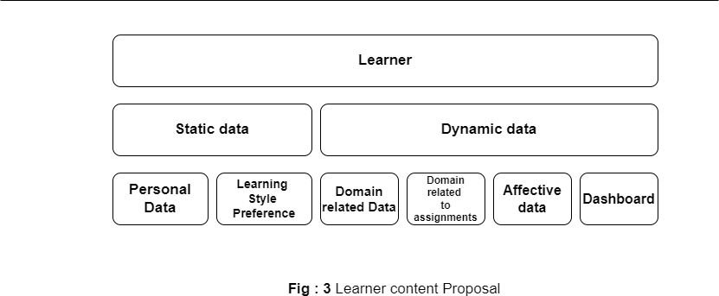

managing their learning trajectory, allowing them to plan future courses upon completing current ones.
These parameters are categorized into two classes, as illustrated in Fig. 3: Static Information and Dynamic Infor- mation. The former comprises Personal Data and Learning Style Preference, collectively forming the learner profile. Conversely, the latter encompasses Domain-related Data, Assessment-related Data, Affective Data, and Dashboard functionalities.
  - Characterizing the Learner: Following the delineation of various parameters for the learner’s model in the preceding section, the subsequent step involves deter- mining methods and techniques for collecting and rep- resenting these parameters. This entails drawing from existing methodologies in the literature, including the Overlay Model (Reddy and Sasikumar, 2014; Sosnovsky and Brusilovsky, 2015 [12]), Stereotype Model (Tsiriga and Virvou, 2002), Fuzzy Logic Model (Sweta and Lalet, 2017; Peña-Ayala and Sossa, 2013 [13]), Perturbation Model (Tourtoglou and Virvou, 2008, 2012 [14]), and Bayesian Methods (Conati and MacLaren, 2009 [15]). These methodologies elucidate how the model will be developed and managed to enhance learner retention, quality, and efficiency of learning.
To craft an adaptive and intelligent model, our approach
integrates the stereotype method with machine learning techniques. The model for each learner encompasses the following components:
- Personal Data: This information is gathered through a pre-learning form provided to the learner.
- Learning Style Preference
- Various models have been developed to characterize how learners engage with information, including the Learning Style Inventory model (LSI) (Kolb, 2014), Felder-Silverman model (Felder and Silverman, 1988 [11]), and VARK model (Fleming and Baume, 2006 ). In our work, we have opted for the Felder Silverman’s model (FSLSM) due to its suitability for our objectives and its recognition as a practical and comprehen- sive model for implementation in e-learning environ-
ments . Additionally, based on this model, Felder and Soloman developed the Index of Learning Style (ILS) questionnaire (Soloman and Felder, 1999 [16]). This questionnaire, comprising 44 questions, categorizes learners into four dimensions: active/reflective, sen- sory/intuitive, visual/verbal, and sequential/global.

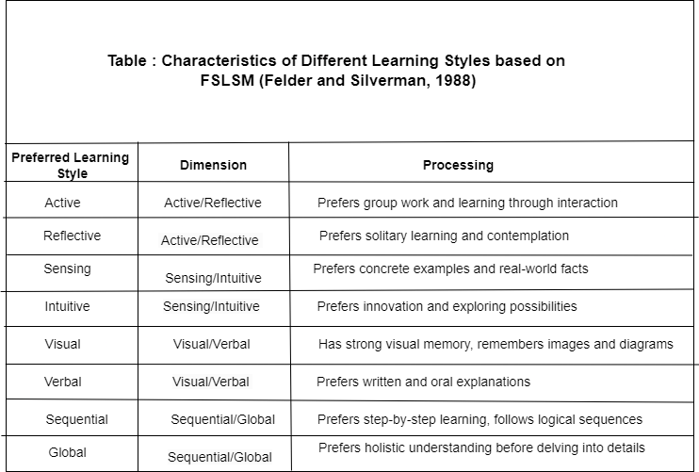
Note : FSLSM - Felder-Silverman Learning Style Model

Despite the effectiveness of the ILS questionnaire, au- thors have noted challenges that learners encounter when completing it. These challenges include the dichotomous nature of certain questions and the desire for intermediate response options. To address this, we propose utilizing fuzzy logic, as proposed by Lotfi Zadeh, to allow learners to express their degree of membership to each answer. This approach contrasts with the traditional method that requires learners to choose whether they belong to a specific answer item or not. Our proposed questionnaire mirrors the ILS but includes six possible answers for each question instead of being dichotomous. Each answer corresponds to a specific rule:
- Rule 1: Strongly leaning towards Extremity A
- Rule 2: Predominantly leaning towards Extremity A with some inclination towards Extremity B
- Rule 3: Primarily leaning towards Extremity B with slight inclination towards Extremity A*
- Rule 4: Occasionally leaning towards both Extremity A and Extremity B
- Rule 5: Strongly leaning towards Extremity B
- Rule 6: No response provided
When the learner selects rule 6 as the answer to a given question, that question will not be factored into calculations.
- Domain-related Data
This parameter, as outlined in the previous section, encompasses three elements: Learning area (category), Learning objectives, and Level of mastery of knowledge.
The first element pertains to the desired learning do- main, identified by the learner. The learner chooses the domain from those presented in the learning environment and determines the objectives that align with their needs. To recommend resources that meet the learner’s needs, there must be a degree of similarity or compatibility between the learner’s expected objectives and those iden-
tified by the instructor for each resource.
To achieve this, we assess the importance of terms in the description of objectives. This importance is calculated

using the TF-IDF (Term Frequency Inverse Document Frequency) measure. Subsequently, a cosine measure is employed to determine the similarity between the vectors of expected and determined objectives. The objectives with the highest cosine similarity value are deemed most similar to the goals anticipated by the learner.
In our methodology, we define (TDOS) as the as- sortment of terms delineating the learner’s anticipated objectives, utilizing TF-IDF to ascertain their significance (1).

T DOS = Tis,....., T ns (1)
Similarly, TDOR encapsulates the terms delineating objectives prescribed by the instructor for the learner’s attainment (2).

T DOR = Ti , ....., T n (2)
Every resource R is symbolized as a vector V R, where V RTi signifies the T F − IDF value of term Ti within the resource description (3).

V R = (V RTi , .....,V RT n) (3)
Furthermore, the T DOR set is depicted as a vector V T DOR (4), where V T DORi signifies the T F −IDF values of term Ti across all objective descriptions post domain selection.

V T DOR = (V T DORi , .....,V T DORn) (4)
Following this, the cosine similarity (5) is computed between the T DOS vector representing the learner’s stated objectives and the T DOR vector signifying the objectives outlined by the instructor.

CosSim(O) V T DOS.V T DOR
=
||V T DOS|| ∗ ||CT DOR||
(5)
The objectives exhibiting the highest CosSim(O) value bear the closest resemblance to the learner’s described objectives.
Furthermore, learners are stratified into Beginner, In- termediate, and Advanced categories based on their test outcomes R administered by the instructor, either at the commencement or conclusion of the course.
  - The Beginner archetype denotes scores of R < 40 % of questions answered correctly,
  - Intermediate signifies 40 % less than equal to R less then 55 %
  - Advanced 55 % less than equal to R less than 100 % Upon entering the system, the learner is initially catego- rized into the Beginner stereotype to address the model
initialization challenge (Tsiriga and Virvou, 2002). Once test results are gathered, the system dynamically assigns the learner to a suitable stereotype aligned with their performance.
Throughout the assessment process, the instructor records the learner’s errors, attempts, and response du- ration to questions. This data not only aids the system in identifying the learner’s state but also enables self- evaluation. For instance, incorrect responses may stem from various factors such as misunderstanding the ques- tion or lack of confidence, aside from knowledge assimi- lation issues.
The number of errors and attempts is constrained within predefined limits, while duration is determined by comparing the instructor-set duration with the learner’s actual response time.
  - Affective Data
Modeling the learner’s state involves two components: facial expression recognition for emotion detection and data utilization to facilitate an optimal learning state.

Conclusion
The architecture of the learner model stands as a fundamental component in the realm of adaptive learning systems, facilitating personalized experiences tailored to individual learners’ characteristics, interests, and needs. It encompasses a meticulous process of data collection and representation, vital for optimizing the learning environ- ment.
Throughout this study, our aim has been to elucidate the intricacies of our learner model architecture, compris- ing a comprehensive array of parameters delineating vari- ous aspects of the learner. Emphasizing the importance of relevant information, our approach underscores the significance of leveraging diverse data points to enhance personalization and improve overall learning efficiency.
We propose an innovative approach that amalgamates the stereotype method, fuzzy logic, and similarity tech- niques for the initialization and continuous updating of the learner model within adaptive environments. This integration ensures adaptability and responsiveness to the evolving needs and preferences of learners, thereby fostering a dynamic and tailored learning experience.
Looking ahead, our future endeavors will focus on advancing the recognition of learners’ emotions and in- tegrating this capability into the personalization recom- mendation system of our learning environment. By in- corporating emotional intelligence into our model, we aim to further refine the adaptability and effectiveness of our personalized learning platform, ultimately enhancing learner engagement and success.
- FINDINGS AND ANALYSIS
In this section, we present a detailed analysis of the findings derived from our case study investigation into personalized learning paths augmented by AI integration. Each objective is meticulously examined to offer specific
insights into the effectiveness, role, accuracy, efficiency, and ethical considerations of AI in enhancing e-learning experiences.

- Objective 1:
Effectiveness of AI-Powered Personalized Learning Paths Our analysis reveals that AI-powered personalized learning paths significantly enhance learner engagement, compre- hension, and retention. Through adaptive content delivery and tailored learning experiences, students exhibit in- creased motivation and satisfaction, resulting in improved learning outcomes.

- Objective 2:
Role of Intelligent Tutoring Systems (ITS) Intelligent Tutoring Systems play a crucial role in providing per- sonalized guidance, feedback, and support to learners. Our findings demonstrate that ITS effectively cater to individual learning styles and preferences, facilitating a more interactive and adaptive learning environment.

- Objective 3:
Accuracy and Efficiency of Automated Assessment Au- tomated assessment tools powered by AI demonstrate high accuracy and efficiency in evaluating student per- formance. By analyzing large datasets and identifying patterns, these tools provide timely feedback and person- alized recommendations for improvement, thereby opti- mizing the learning process.

- Objective 4:
Ethical Considerations of AI Integration Ethical con- siderations surrounding AI integration in e-learning en- vironments are paramount. Our analysis highlights the importance of ensuring data privacy, mitigating algorith- mic bias, and promoting equitable access to educational resources. Ethical frameworks and guidelines are essential to safeguarding learner rights and ensuring responsible AI usage.

- Objective 5:
Recommendations for Future Research and Practice Based on our findings, we offer specific recommendations to guide future research and practice in AI-integrated e-learning. These include the development of transpar- ent algorithms, the promotion of learner autonomy, the enhancement of diversity and inclusivity, and the es- tablishment of ethical guidelines to govern AI usage in educational settings.
Through a nuanced examination of these objectives, our study provides actionable insights for educators, policy- makers, and researchers seeking to leverage AI to enhance e-learning experiences. By addressing key challenges and opportunities, we aim to drive meaningful advancements in AI-integrated education.
- DISCUSSION

Key Insights from Case Studies
In this section, we synthesize the key insights gleaned from our case study analysis of personalized learning paths fortified by AI integration. By considering the find- ings in conjunction with existing literature and theoretical frameworks, we illuminate the broader implications and potential ramifications of leveraging AI in e-learning en- vironments.
In our case study, we outlined various learner charac- teristics identified through literature review, along with the techniques and models utilized for learner modeling. These characteristics predominantly include knowledge, cognitive factors like memory and attention, affective as- pects such as emotion, personality traits, and motivation. This finding resonates with the research conducted by Raj and Renumol (2021), which highlighted learning style, learner preferences, knowledge level, learning paths, and patterns among the most utilized attributes for learner modeling in adaptive content recommender systems from 2015 to 2020.
In the realm of adaptive learning environments, dis- orientation and cognitive overload emerge as significant challenges. Scholars have underscored the importance of addressing the affective aspect in tackling these issues Shephard, 2008 [17]; Snow & Farr, 2021 [18] , suggesting a need for holistic perspectives in theoretical frameworks.
An essential element frequently incorporated into learner models is the level of knowledge mastery, reflect- ing the primary objective of learning endeavors. While the overlay model is commonly used to represent the learner’s knowledge level (Chrysafiadi & Virvou, 2013 [7]), our approach integrates fuzzy logic with stereotypes to account for the uncertainty inherent in knowledge.
Learning style, pivotal for personalization in learning, has garnered considerable attention in research. Notably, the FSLSM and VARK models are frequently employed, with the stereotype model proving particularly apt for modeling learning styles and preferences (Chrysafiadi & Virvou, 2013 [7]). In our study, we employed the FSLSM questionnaire for modeling learning styles, augmented with fuzzy logic to offer nuanced response options.
- Furthermore, our model incorporates additional critical characteristics:
  - Domain-related data: These delineate the learner’s anticipated needs, encompassing desired domain, learning objectives, and level of knowledge mastery.
  - Data related to assessments: These provide insights into the learner’s knowledge and status, crucial for accurate mastery level determination. Our model integrates sub-parameters including the number of attempts, errors, and response duration.
  - Affective data: These exert influence on the learn- ing process, and their recognition can be achieved through various methods such as facial recognition,
voice analysis, and gesture recognition, among others (Imani & Montazer, 2019 [4]).

- Implications for AI Integration in E-Learning
The findings from our case studies have significant implications for the broader integration of AI into e- learning environments:
- Personalization Paradigm Shift: AI-driven person- alized learning represents a paradigm shift in e- learning, moving away from one-size-fits-all ap- proaches towards tailored, learner-centric experi- ences. Embracing this shift requires a reevaluation of traditional pedagogical practices and a commitment to learner empowerment.
- Educational Equity and Access: AI-powered person- alized learning has the potential to bridge educa- tional disparities by providing equitable access to high-quality learning resources and support. How- ever, efforts must be made to address digital divide issues and ensure that AI technologies are accessible to all learners, regardless of socioeconomic back- ground.
- Continuous Innovation and Adaptation: As AI tech- nologies evolve, so too must e-learning environ- ments. Continuous innovation and adaptation are essential to harnessing the full potential of AI in education. This necessitates ongoing research, col- laboration between stakeholders, and a willingness to embrace emerging technologies.
- Human-AI Collaboration: While AI can enhance var- ious aspects of the e-learning experience, it is not a substitute for human educators. The most effective educational environments leverage the complemen- tary strengths of both AI and human instructors, fostering collaborative learning ecosystems that pri- oritize learner success and well-being.
In conclusion, the integration of AI into e-learning holds immense promise for enhancing educational experi- ences and outcomes. By leveraging AI-driven personalized learning paths, educators can create dynamic, adaptive learning environments that empower learners to achieve their full potential. However, realizing this potential re- quires careful consideration of ethical, pedagogical, and practical considerations, ensuring that AI technologies are harnessed responsibly and inclusively for the benefit of all learners.

- CONCLUSION

In this study, we conducted a comprehensive examina- tion of the integration of AI into e-learning environments, focusing specifically on the implementation of personal- ized learning paths. Through a series of case studies, we explored the effectiveness, implications, and challenges associated with this innovative approach to education.
- Summary of Findings
Our findings highlight the transformative potential of AI-powered personalized learning paths in enhancing e- learning experiences. Key outcomes include:
  - Improved Engagement and Retention: AI integration led to increased learner engagement and retention rates, fostering a more dynamic and interactive learning environment.
  - Enhanced Learning Outcome: Personalized learning paths tailored to individual needs and preferences resulted in improved learning outcomes, with learn- ers achieving mastery at their own pace.
  - Efficiency and Scalability: AI-driven tools such as intelligent tutoring systems and automated assess- ments streamlined the learning process, promoting efficiency and scalability in educational delivery.
  - Ethical Considerations: While AI integration offers promising benefits, ethical considerations regarding data privacy, algorithmic bias, and the deperson- alization of learning experiences must be carefully addresse

- Limitations and Future Research Directions
Despite the promising outcomes, our study is not with- out limitations. Key limitations include:
  - Generalizability: The findings of our case studies may not be fully generalizable to all e-learning contexts. Future research should aim to replicate and validate our findings across diverse educational settings and learner populations.
  - Ethical Challenges: Ethical considerations surround- ing AI integration in e-learning remain complex and multifaceted. Further research is needed to develop robust ethical frameworks and guidelines to ensure responsible AI use in education.
  - Technological Advancements: As AI technologies continue to evolve, ongoing research is necessary to assess their impact on e-learning and identify new opportunities for innovation and improvement.
  - Pedagogical Integration: The effective integration of AI into e-learning requires careful consideration of pedagogical principles and practices.
In conclusion, our study underscores the transforma- tive potential of AI in enhancing e-learning experiences through personalized learning paths. By addressing the identified limitations and charting future research direc- tions, we can further harness the power of AI to create inclusive, engaging, and effective learning environments for all learners.

REFERENCES

- A. Abyaa, M. Khalidi Idrissi, and S. Bennani, “Learner modelling: systematic review of the literature from the last 5 years,” Educational Technology Research and Development, vol. 67, no. 5, pp. 1105–1143, Oct 2019. [Online]. Available: https:
//doi.org/10.1007/s11423-018-09644-1
- Z. Jeremic´, J. Jovanovic´, and D. Gaševic´, “Student modeling and assessment in intelligent tutoring of software patterns,” Expert Systems with Applications, vol. 39, no. 1, pp. 210–222, 2012. [Online]. Available
- R. Pelánek, J. Papoušek, J. Rˇihák, V. Stanislav, and J. Nižnan,
“Elo-based learner modeling for the adaptive practice of facts,” User Modeling and User-Adapted Interaction, vol. 27, no. 1, pp. 89–118, Mar 2017. [Online]. Available: https://doi.org/10.1007/
s11257-016-9185-7
- M. Imani and G. A. Montazer, “A survey of emotion recognition methods with emphasis on e-learning environments,” Journal of Network and Computer Applications, vol. 147, p. 102423, 2019. [Online]. Available
- K. Tourtoglou and M. Virvou, “An intelligent recommender system for trainers and trainees in a collaborative learning environment for uml,” Intelligent Decision Technologies, vol. 6, pp. 79–95, 2012,
2. [Online]. Available: https://doi.org/10.3233/IDT-2012-0125
- J. Wang, H. Xie, F. L. Wang, L.-K. Lee, and O. T. S. Au, “Top-n personalized recommendation with graph neural networks in moocs,” Computers and Education: Artificial Intelligence, vol. 2, p. 100010, 2021. [Online]. Available
- K. Chrysafiadi and M. Virvou, “Student modeling approaches: A literature review for the last decade,” Expert Systems with Applications, vol. 40, no. 11, pp. 4715–4729, 2013. [Online]. Available
- M. Riyahi and M. K. Sohrabi, “Providing effective recommendations in discussion groups using a new hybrid recommender system based on implicit ratings and semantic similarity,” Electronic Commerce Research and Applications, vol. 40, p. 100938, 2020. [Online]. Available
- N. P. De Koch, “Software engineering for adaptive hypermedia systems,” Ph. DThesis, Verlag Uni-Druck, Munich, 2001.
- L. Nguyen and P. Do, “Combination of bayesian network and overlay model in user modeling,” pp. 5–14, 2009.
- L. K. Silverman and R. Felder, “Learning and teaching styles in engineering education,” Engineering education, vol. 78, no. 7, pp. 674–681, 1988.
- S. Sosnovsky and P. Brusilovsky, “Evaluation of topic-based adaptation and student modeling in quizguide,” User Modeling and User-Adapted Interaction, vol. 25, no. 4, pp. 371–424, Oct 2015. [Online]. Available: https://doi.org/10.1007/s11257-015-9164-4
- A. Peña-Ayala and H. Sossa, “Proactive sequencing based on a causal and fuzzy student model,” pp. 49–76, 2013. [Online].
Available: https://doi.org/10.1007/978-3-642-30171-1_3
- K. Tourtoglou and M. Virvou, “User stereotypes concerning cognitive, personality and performance issues in a collaborative learning environment for uml,” pp. 385–394, 2008. [Online].
Available: https://doi.org/10.1007/978-3-540-68127-4_40
- C. Conati and H. Maclaren, “Empirically building and evaluating a probabilistic model of user affect,” User Modeling and User- Adapted Interaction, vol. 19, no. 3, pp. 267–303, Aug 2009. [Online].
Available: https://doi.org/10.1007/s11257-009-9062-8
- B. Soloman and R. Felder, “Index of learning styles questionnaire,”
Learning, 01 1999.
- K. Shephard, “Higher education for sustainability: Seeking affec- tive learning outcomes,” International Journal of Sustainability in Higher Education, vol. 9, 01 2008.
- F. M. E. Snow, R.E., “Aptitude, learning, and instruction,” Conative and Affective Process Analyses (1st ed.), vol. 3, 1987.

